Experiment VII
The Separation of Three Organic Compounds by Acid-Base Reactions and Liquid-Liquid Extractions

Abstract:
The purpose of this experiment was to extract and separate benzoic acid, benzocaine, and 9-fluorenone using acid-base reactions and liquid-liquid extractions. Each compound was poured into a culture tube and mixed together. Benzoic acid was the acidic component; benzoic acid the basic component; 9-fluorenone the neutral component. Acid-base reactions and liquid-liquid extractions are commonly used to separate organic compounds from a mixture. Each component was separated and then extracted in solid form using vacuum filtration. Benzoic acid was separated by using 2mL of 3M NaOH and 6M HCL. Benzocaine was separated by using 2mL of 3M HCL. To separate and extract 9-fluorenone, 2mL of 3M NaOH was used and the bottom organic layer was collected and dried with sodium sulfate. I managed to extract 25mg of benzocaine, 36mg of benzoic acid, and 46 mg of 9-fluorenone. The observed melting points were: benzocaine 89.5-91.5°C; benzoic acid 120.5-122.5°C; 9-fluorenone 64.5-71°C.
Procedure:
Poulos, Z. J. Organic Chemistry I – A Laboratory Manual for the Health Sciences Major, Fall 2017; Hayden-McNeil: Plymouth, MI, 2017.
Refer to pages 111-120 of the Lab Handbook for the full list of equipment used and the detailed procedure. I measured and used 55mg of benzocaine, 59mg of benzoic acid, and 53mg of 9-fluorenone. All of these components were put into the same culture tube and dissolved using 2mL of methylene chloride. All liquid measurements was done using a plastic disposable pipette. Nothing in the procedure was changed and all three precipitants were collected.

Reactions:
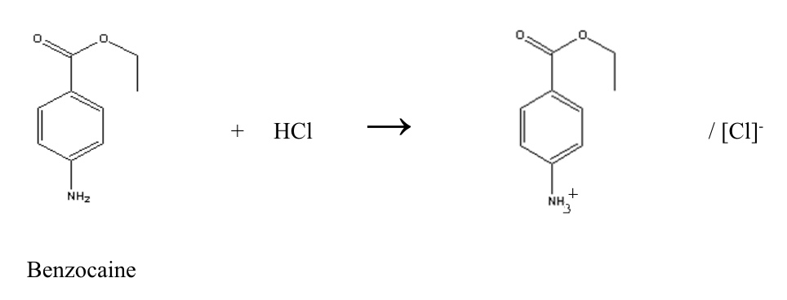
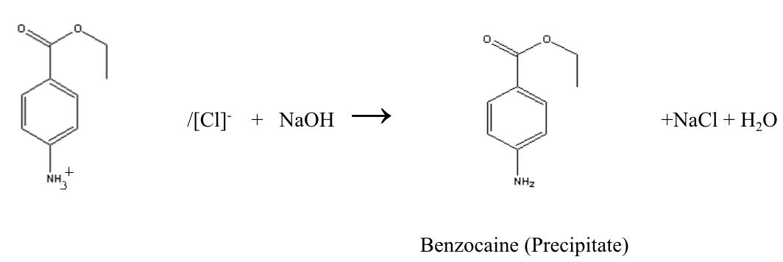
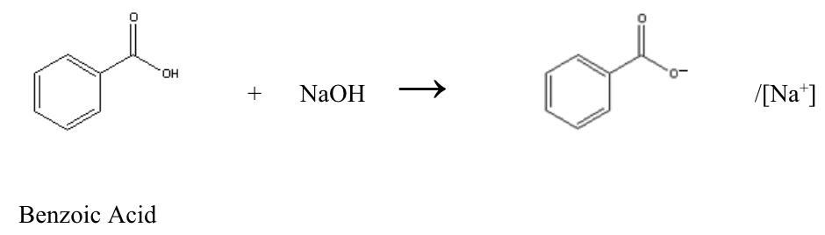

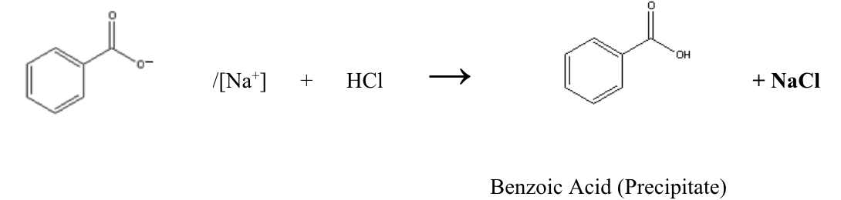

Data/Calculations
Table 1. Recorded and Calculated Data
 | Starting Mass | Mass of Tared Dish/ Culture tube | Mass of Dish/ Culture Tube With Compound | Recovered Mass | % Yield | Actual Melting Point | Observed Melting Point
Benzocaine | 55mg | 413mg | 438mg | 25mg | 45% | ~88-90°C | 89.5-91.5°C
Benzoic Acid | 59mg | 412mg | 448mg | 36mg | 61% | ~122.12°C | 120.5-122.5°C
9-Fluorenone | 53mg | 11,503mg | 11,549mg | 46mg | 87% | ~83.5°C | 64.5-71°C

Recovered Mass
= (Mass of Tared Dish/Culture Tube) – (Mass of Dish/Culture With Compound)
- Benzocaine
438mg – 413mg = 25mg
- Benzoic Acid
448mg – 412mg = 36mg
- 9-Fluorenone
11,549mg – 11,503mg = 46mg
% Yield
= [(Recovered Mass) / (Starting Mass)] x 100%
- Benzocaine
[(25mg / 55mg)] x 100% = 45%
- Benzoic Acid
[(36mg) / (59mg)] x 100% = 61%
- 9-Fluorenone
[(46mg) / (53mg)] x 100% = 87%

Infrared Spectrums
Table 2. IR Spectrum of Benzocaine
Peak Wavenumber (cm⁻¹) | Functional Group/ Bond | Interpretation
3222-3454 cm⁻¹ | N-H | Stretch, broad
1679 cm⁻¹ | C=O (amide) | Stretch, strong
1595 cm⁻¹ | C=C ring | Sharp, weak
1273 cm⁻¹ | C-O | Has more sp^2 character than normal
1026 cm⁻¹ | C-O (ester) | Stretch
770 cm⁻¹ | =C-H oop bend | Position can be correlated to pattern of substitution

Table 3. IR Spectrum of Benzoic Acid
Peak Wavenumber (cm⁻¹) | Functional Group/ Bond | Interpretation
3017 cm⁻¹ | =C-H | Stretch
2555-2827 cm⁻¹ | O-H | Stretch, may show beard of overshadowed C-H stretches
1678 cm⁻¹ | C=C | Stretch, medium, weak, sharp
1453 cm⁻¹ | C=C benzene ring | Stretch, sharp
1289 cm⁻¹ | C-O | Stretch, more sp^2 character than normal
1000-1186 cm⁻¹ | C-O | Stretch, strong
932 cm⁻¹ | =C-H oop bend | Position can be correlated to pattern of substitution
704 cm⁻¹ | =C-H oop bend | Position can be correlated to pattern of substitution

Table 4. IR Spectrum of 9-Fluorenone
Peak Wavenumber (cm-1) | Functional Group/ Bond | Interpretation
3014-3396 cm⁻¹ | =C-H | Stretch, medium, sharpish
1711 cm⁻¹ | C=O | Stretch, strong
1598 cm⁻¹ | N-H | Bend, medium
650-955 cm⁻¹ | =C-H oop bend | Position can be correlated to pattern of substitution
Discussion
The main techniques used in this experiment were liquid-liquid extractions and acid-base reactions. For the case of this experiment, liquid-liquid extraction was used to extract each of the components from the initial mixture of benzocaine, benzoic acid, and 9-fluorenone. The initial 1:1:1 mixture was dissolved in 2 mL of methylene chloride. To separate each component, an acid-base reaction was used. To separate benzocaine, we performed a 2 x 2mL 3M HCl extraction. We first added 2mL of 3M HCl to the initial mixture to separate the benzocaine from the benzoic acid and 9-fluorenone. Two layers formed, the aqueous top layer, and the bottom organic layer. Being a base, benzoic acid accepts the proton from the HCl and becomes positively charged, making it aqueous. The organic layer consists of benzoic acid and 9-Fluorenone. The top aqueous layer, which contains benzocaine’s conjugate acid, was then extracted using a pipette. To precipitate the benzocaine, 2mL of 6M NaOH was added to the aqueous benzocaine. The OH⁻ acts as a base and takes the extra proton that was on the conjugate acid. The benzocaine free base then precipitates out of the aqueous solution as this process occurs. The addition of 2mL 3M HCl and the aqueous layer extraction was done twice. To separate the benzoic acid, we performed a 2 x 2mL 3M NaOH extraction. The OH⁻ takes a proton from benzoic acid making it negatively charged. Sodium benzoate, the conjugate base, is formed and dissolved in the aqueous layer. We then collected the top aqueous layer. This process was done twice. To precipitate the benzoic acid, we added 2mL of 6M HCl to the aqueous solution. The sodium benzoate will take a proton from HCl and precipitate out of solution as benzoic acid. To extract the final compound 9-fluorenone, which is neutral, we performed a 2 x 1mL deionized water extraction. Two aliquots of 1mL deionized water was placed into the tube one at a time. The purpose of the water was to remove any excess NaOH and any left over sodium benzoate. The aqueous top layers were extracted, since the bottom organic layer contains the dissolved 9-fluorenone. The organic layer was then dried with anhydrous sodium sulfate. The precipitates from each separation was extracted using vacuum filtration.
My percent yield for benzocaine was 45%, for benzoic it was 61%, and for 9-fluorenone it was 87%. The observed melting points were 89.5-91.5°C for benzocaine, 120.5-122.5°C for benzoic acid, and 64.5-71°C for fluorenone. The percent yields for benzocaine and benzoic acid were relatively low. However, the melting points were relatively similar except for 9-fluorenone; the literature melting point is ~83.5°C, but my observed value is over 10 degrees lower. The low recovery percentages for benzocaine and benzoic acid can most likely be appointed to human error. I had a hard time getting all of the components into the initial mixing tube and lost some amounts of each compound due to spillage. Another source of human error that could have occurred is not getting all of the precipitates out of the Erlenmeyer flasks during the extraction process. I may have failed to get all of the solid out and onto the filter paper. I believe the largest source of human error occurred when scraping the benzocaine and benzoic acid off the filter paper following vacuum filtration. I had a difficult time scraping all of the products off the filter paper as well as on the side of the funnel. I had some of the products on my gloves and small pieces on the table that got smudged. This would definitely lead to a lower mass reading and lower percentage yield. The observed melting points for benzocaine and benzoic acid were almost spot on; however, my recorded value for 9-fluorenone was over 10 degrees off. This may be due to impurities in my collected precipitate. There may still have been water in the precipitate or something contaminated it when I was extracting it from the culture tube. I could have also used too little of the substance when testing for its melting point. Of all the tubes put into the machine, the tube with 9-fluorenone had the least solid in it, since it was the most difficult to get the solid down. All the crystals in my sample dissolved in 64.5-71°C range. Since I used too little, all of the few crystals that were contained in the tube might have dissolved before the actual melting temperature. If I had used more, there would have been more crystals that should have not melted until the melting point.
The IR spectrum for benzocaine has peaks of similar size at 3222-3454 cm⁻¹ which should correspond to its amine (N-H) functional group. Another notable peak is at 1273 which is a C-O stretch, but it shows that there is more sp^2 character than normal, which can be appointed to the two oxygens. As for benzoic acid, there is also more sp^2 character than normal, shown at the 1289 cm⁻¹ C-O functional peak. There are also more C-O stretches from 1000 to 1289 cm⁻¹. There are also peaks at 2555 to 2827 cm⁻¹ which correspond to an O-H functional group. A peak at wavenumber 1453 cm⁻¹ also shows there is a C=C benzene ring. For 9-Fluorenone, there is a really sharp peak at 3014-3396 cm⁻¹ which corresponds to a =C-H stretch. Furthermore, at 1598 cm⁻¹ there is an amine stretch
The literature melting points for each of the compounds from lowest to highest goes as followed: 9-fluorenone, then benzocaine, and then benzoic acid. A large portion of this can be appointed to the polarity and resonance of each compound. Although none of the compounds are normally polar, the melting points can be rationed from the intermolecular forces. 9-Fluorenone has three cyclic rings and a double bonded oxygen. There is a lot of resonance in this structure due to the cyclic rings, which is why it has the lowest melting point. As for benzoic acid and benzocaine, each compound has one benzene ring. However, if we look at the intermolecular forces, benzocaine has more dipole moments due to its amine group. The amine group makes it more soluble and more able to hydrogen bond considering it has two hydrogens on the nitrogen. Benzoic acid only has the carboxylic group, making it less able to hydrogen bond.

